Cube Humidity Controller - Documentation

Leaf Controller

[24th February 2021]

Document Control Number:

Revision Number: 0.1

Expiration Date:

Author: Kai Weber

Approval: ____________________________________

Revision History

|  |  |  |
| --- | --- | --- |
| Date | Revision Number | Pages Affected |
| 20th February 2021 | 0.1 | Initial release |

Table of Contents

1. Using the Modbus Script 2

2. Functionality 2

2.1 Table of actions 3

2.2 SW Control Logic 4

3. Implementation 5

# Using the Modbus Script

The script should be located in the directory /usr/local/bin on the banana pi. It can be started with the following command:

fluence_controller.py

The script implements the functionality, as described in the PowerPoint presentation “Cube humidity control”.

# Functionality

The following table of actions and flowchart from the PowerPoint presentation “Cube humidity control”, describe the functionality.

## Table of actions

|  |  |  |  |
| --- | --- | --- | --- |
| **Condition #1**  **[Tair]** | **Condition #2**  **[RH limit exceeded]** | **Set-point** | **Action until** |
| Tair < 15°C | N/A | 15°C | Heat until Tair = SP |
| 15°C < Tair < 18°C | RH > 85% | 15°C | [Cool until Tair = SP] OR [max 1h] OR [RH – 10%] (*) |
| 18°C < Tair < 21°C | RH > 75% | 17°C | [Cool until Tair = SP] OR [max 1h] OR [RH – 10%] (*) |
| 21°C < Tair < 24°C | RH > 62% | 20°C | [Cool until Tair = SP] OR [max 1h] OR [RH – 10%] (*) |
| 24°C < Tair < 27°C | RH > 53% | 23°C | [Cool until Tair = SP] OR [max 1h] OR [RH – 10%] (*) |
| 27°C < Tair < 30°C | RH > 45% | 25°C | [Cool until Tair = SP] (**) |
| T > 30°C | RH > 40% | 25°C | [Cool until Tair = SP] (**) |

## SW Control Logic

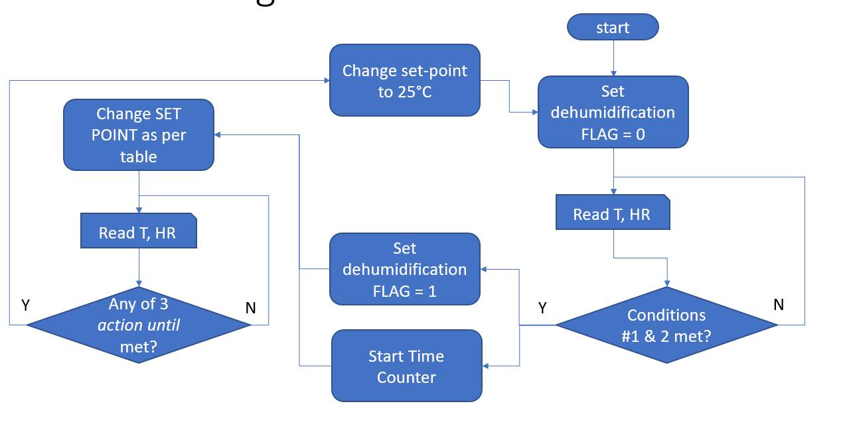

# Implementation

The script will initialize itself, by reading the configuration from the same config file, that is also used by the script controllino_modbus.py.

By reading the config file, the script will know if it is running in a Cube or OCTE and furthermore if one or two HVACs are connected to the Cube Controller.

After the initialization, the main functionality is implemented in a while-true loop with the following steps:

1. Derive temperature, humidity and dl10 read alarm from dl10 sensor
2. Check if values of dl10 are valid and dl10 read alarm status
   1. The values are valid, and the read alarm is false
      1. Calculate the setpoint for the HVACs depending on the temperature, humidity and the time elapsed since the current setpoint has been set
      2. Write the new setpoint to the HVACs.
      3. Sleep for ten seconds.
      4. Return to step 1.
   2. The values are invalid, or the read alarm is true
      1. Write emergency value for refrigeration stop point of 20°C to the HVACs.
      2. Sleep for ten seconds.
      3. Return to step 1.